Week 1

Day 1:

Intro to virtualization

Creating a simulated version of an object is virtualization. There are two main types - hardware and bare-metal.

Bare-metal or bare machine refers to the hard disk or hardware that the OS is installed on. While hardware virtualization is a process that fundamentally hides the physical components and uses software to control and create the simulated environment. Hypervisor is used for this.

After virtualization is done different OSs can be installed and apps can run.
With bare-metal only hardware is shared with guests.

Process of Bare-metal
To have bare-metal virtualization you need the host computer/ physical machine, abstraction, hypervisor, guest Virtual machine (VM)

- Abstraction is done by abstracting the physical hardware of the host computer (by hypervisor)
- Hypervisor - software tasked with managing physical hardware resources between host and guest
- VM is the emulated equivalent of a computer system that runs on top of another. The guest VM runs simultaneously by the host machine and the two share resources but separate OS.

“The use of abstraction layer to simulate computing hardware so multiple OS can run on a single computer” - National Institute of Standards and Technology

Bare-metal virtualization uses specific type of hypervisor (type 1 or bare-metal hypervisor).
Type 1: hypervisors isolated from the OS and therefore less prone to attacks. They stand in for OSs and communicate directly with industry standard architecture ( ISA). type 1 replicate the hardware allowing guests to be managed. Due to running on the hardware it is also called a native virtual machine.

Hosted virtualization is done on top of the OS
Type 2: hypervisor runs as a software layer on an OS. The kernel of the OS allows more than one isolated user-space to exist - called software containers. The OS kernel will run single OS and provide functionality to replicate on each isolated partition. VM resources are scheduled against a host OS. Also known as a hosted VM

Hosted virtualization requires physical/host machine, OS installed on hardware, type 2 hypervisor within the OS and guest VM instances.
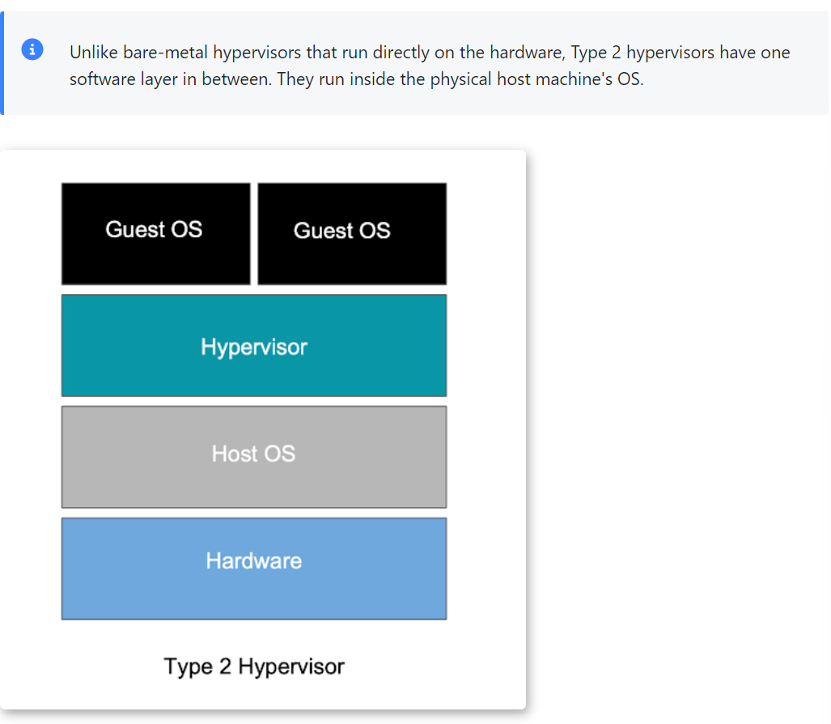

Virtualized Environments
Referring to a software-based simulation of specific comp. hardware or network environment - that allows multiple VMs to run on one host machine. Each VM runs like a separate entity with its own resources. Both bare-metal and hosted virtualization processes use hypervisors to provide guest access.

VM is simulated environments or virtual machines that emulate or represent a physical computer - IBM.

When the virtual machine is stored on a virtual disk it is referred to as a disk image. May contain the files from a VM to boot or any other specific storage needs. It is opened within the hypervisor software and runs a completely separate machine on top of your desktop.
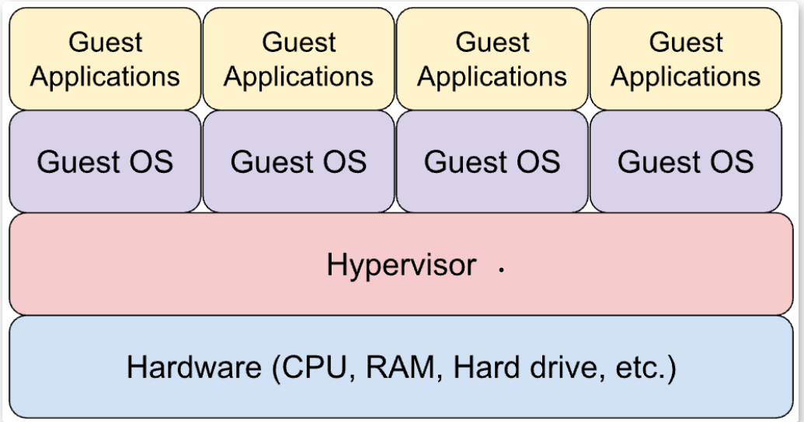
—-----

The hypervisor has its own device drivers and interactions with the OS. To best utilize the hardware a hypervisor may allow installation of multiple guest OSs.

Containerization
One challenge with hosted virtualization is if a very small host OS with multiple guest OSs, resources can become scarce. Way to work around this issue is containerization. Running applications in isolation from each other but on the same OS. Additionally due to the container not being dependent on a particular OS or set of hardware - they can be moved from one environment to another easily.

One downfall is security is more limited between containers then that separating whole OSs

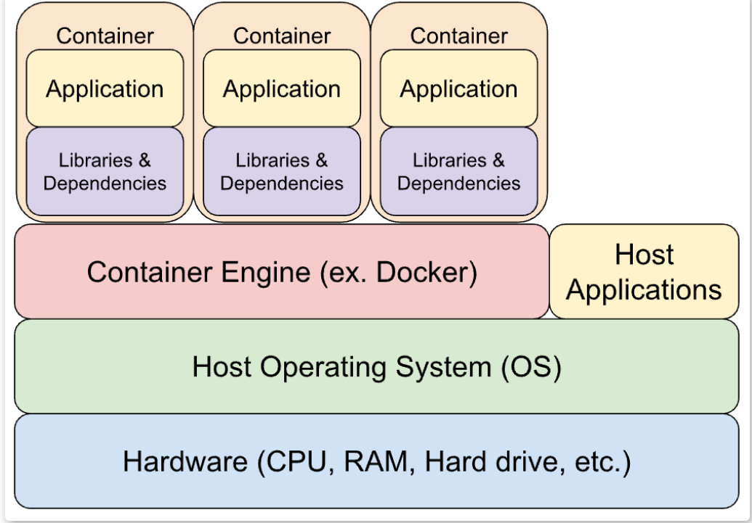

Benefits and downfall of virtualization
Pros
- Better utilization of resources while segregating functions and features
- Easy backup - since VMs and containers are files
- Easy moving of environment to another set up
Cons
- Security setup is not necessarily to protect guest machines
- Some software processes require direct hardware access to function properly
- Real-time processing must be completed before a certain deadline - may not work well
  - ie) clocking issues

Readings recommended
What is Virtualization? | Bare Metal vs Virtual Machines vs Containers

Optional
Bare Metal Environment
What Are Virtual Machines?
What is a Hypervisor? Types of Hypervisors 1&2
Hardware Based Virtualization
How Virtualization Happens

Virtual Box Passwords
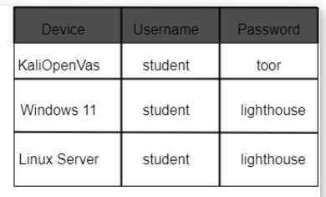
Your PCs hardware resources are shared between all of your virtual machines, so shut down virtual machines when no in use - to make things run nice

Snapshots are a way of backing up virtual machines. Key for when something goes wrong or breaks with the virtual machine.

How to share files over VMs
https://drive.google.com/file/d/1H0dfR3mSbL-_6bCmQTKs4lede9lUeAE8/view

Linux and Windows - what is different
OSs are collections of software that manages comp. hardware resources most widely known are windows and linux.

Intro to MS windows
Developed by Microsoft and released in 1985, MS windows is the most used OS in the world. Closed-sourced copyrighted code, so the source code is unavailable to view or modify. Only compiled (coded) version can be used,

Est, 9/10 users have windows installed - easily adaptable and has numerous software packages compatible. Latest OS version is Windows 11 that is regularly updated by microsoft. Despite advantages, there are negatives like BSOD.

Blue screen of death (BSOD): an error screen displayed when window OS encounters a critical error that it can't recover from.

The vast adoption of windows has major cybersecurity dilemma as it does not require IT for use and security making it an easy target for hackers to have a wide impact if successful

Intro to Linux
Developed as an open source OS using C and assembly. Has become one of the most used OSs in the world - the source code is a human readable version of the software available to the public. First released in 1991 and is MS windows rival.

Linux is a unix-based system that makes it easy for users to use the latest GNU/linux OS.
- The GNU project
  - Started 1983, richard stallman
  - Wide range of tools for unix-like OSs
  - Composed of many different programs including linux kernel.

The Linux kernel is central for controlling communication between hardware and software. Linux was created by Linus Torvalds in 1991. Today the GNU library and the linux kernel form a complete OS that is often referred to as linux but is technically GNU/linux.

It supports more than 150 languages and targets general user markets.

Key differences include Linux’s open-source philosophy - being a decentralized and collaborative project. Richard Stallman, founder of free software foundation (FSF) - copyleft linux to grant it open source license.
- Copyleft - is a type of open-source license that allows users to freely use, distribute, and modify the software within specific restrictions.

Many software companies use Linux distributions as the foundation for their products and services, including Red Hat, Debian, Ubuntu, Yellow Dog, and SUSE, to name a few.

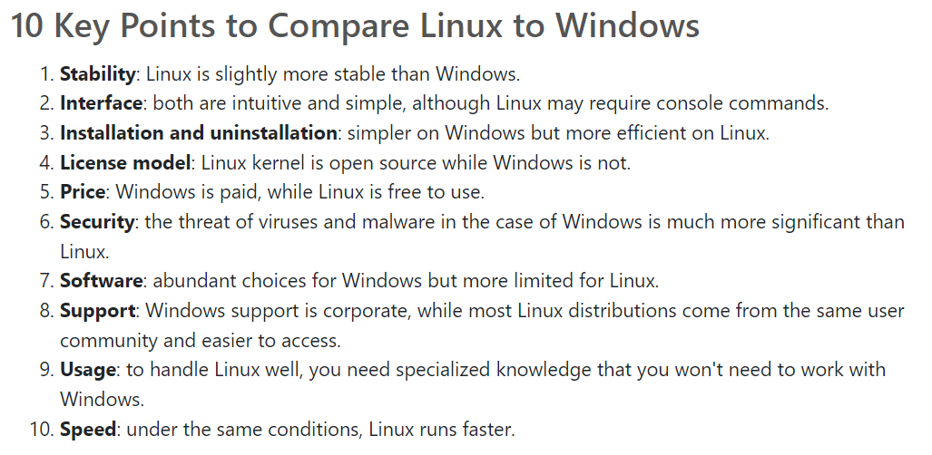

Company uses
In the last few years Microsoft has changed the concept of the license and the use of linux so the company decided to integrate windows and linux to start using Azure cloud servers. Microsoft developed linux-based OS for azure cloud services - allowing for command line tools and applications without the overhead traditional VMs or dual-boot set up

Similarly, google uses linux as primary OS for its servers and runs service on it. Like amazon, IBM, facebook, other tech giants use linux OS.

How linux is organized
Linux file systems is defined by a standard called filesystem Hierarchy standard (FHS). the FHS evolved from older versions of Unix like the Berkeley software distribution (BSD).

When you open the terminal application and use the command LS with the "-l" parameter to list all directories on the "/" root directory, you will see many directories on the list. Aka “ls -1 /”

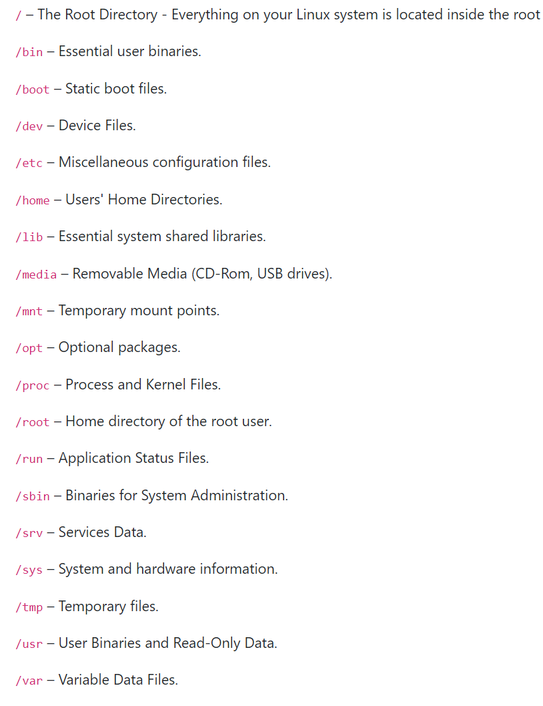

Virtual Network Configuration
Pdf of steps to change IP addresses and to add nat network to VMs
NAT = Network address Translation
https://drive.google.com/file/d/1GKsZacGik5oE8DTu6AJ6e9TNo3QFtLJd/view

Linux Constraints and Capabilities
Linux has the ability to have multiple users who have access at the same time. For ideal security its key to understand how to control permissions to resources

Linux can be one of the most secure systems because it allows admin to creat multiple users with varius permissions on the same hardware. For the multi user design to work right, permissions are required so users are protected from each other. Permissions are “rights” to act on a file or directory.

Basic rights include read, write, execute
- Read - contents of file can be viewed and for the directory to list the contents of directory
- Write - file can be modified. For directory allows editing content of directory and add/delete files.
- Execute (file) - allows you to run the file and execute the program
- Execute (directory) - allows changes to a different directory and make it your current working directory. Users usually have default group

User groups
User group is a collection of users. The purpose of user groups is to define a set of privileges shared by the members.

- Primary groups
  - Only one primary group per person (think job title in a company)
  - User belongs by default and any new file or directory made by the user is associated with the primary group,
- Secondary group
  - Group a user is added to after their account is created.
  - Can belong to no secondary group or multiple (up to 15).

Linux alphabet permission format
example) drw-r— --x
- Letter d means directory, while a - would be a file
- rw- refers to an owner who can read and write.
- r-- is the third section saying what user group owns the object. The r indicates those in the group can read the contents.
- The last - - x indicates what everyone else can do with the file. Here everyone can execute.

Linux permissions
To view file permissions, ownershops and directories use ls -al command.
The -a shows hidden files while l lists the files with complete information.

If there is a dash instead of permission it means that particular permission is removed.
Additionally everything in linux is considered a file, including directories. As well directory size is usually 4096 bytes. - though the size isnt reflective of real size but rather the default value.

Numeric permissions
Translating the alphabetical format to numeric
- Execute = 1
- Write = 2
- Read = 4
- Then add and subtract the numbers in alphabetical format.
https://chmod-calculator.com/

examples)
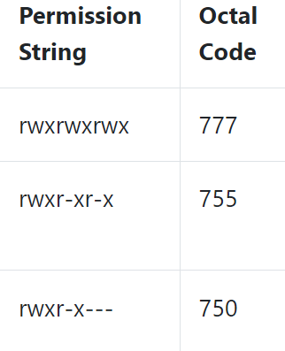

How to connect linux for VM
https://drive.google.com/file/d/1_OSCbz62OQyflnXZNGp-eQnuCabotpvr/view

Day 2:
Lecture plan
Part 1: Review - Virtualization Overview
In this section, your instructor will cover the basics of virtualization, how it works and why we use it.

Part 2: basics of the Linux operating system, including:
- What is Linux?
- Linux file & user permissions
- How is Linux different from Windows or Mac?
- Why do we use Linux?
- What does Linux look like?

Part 3: Demonstration
Managing Linux Processes and Software

This section will be a demonstration, showing you how to manage software and processes within Linux environments, including:

What are processes?
How do we and why do we need to manage processes?
How does software installation work differently in Linux than in Windows or Mac?

Part 4: Task Introduction
Introduction to your Linux Processes and Software task In the last part of this class, you will be introduced to your first tasks in Linux.

Managing Linux Processes
Cybersecurity analysts often run commands to id processes that overconsume. A process is defined as running programs that center an OS, created by linux kernel and representing running operations on the pc. Each process needs resources like CPU time, memory, virtual memory swap, etc.

Processes have a process Identity - can be listed with following information
- PID – Number of the Process ID
  - The PID acts as a unique identifier for any individual process
- PPID – Number of the Parent Process ID
  - The parent process is the process that creates another process. For example, if you start a process for the command line and then start the Apache program. The parent process would be cmd.exe (the command line), and Apache is the child process.)
- Owner – User that starts the process
- Command – Command or parameter that starts the process
- %CPU – Percent CPU used by the process
- %MEM – Percent of Memory (RAM) used by the process

Two main differences between a process and a program is that a program is disk-based to run and contains data/instructions. While a process is memory-based: contains data/ instructions, heap with pre-reserved memory and stack to hold temporary data, parameters and variables.

Initialization of a Process
Use the command ‘ps’ to list all the processes running on a computer system in linux. Include following commands to filter. Each command uses flags - flags are optional inputs.

Linux kernel loads to memory using initramfs (initial RAM file System) - happens when computer boots. The process is the init process, but as linux evolved it was replaced with systemd process of initialization. Except for the launch of the initial process, the initialization steps of the OS are loaded into a reserved memory space called kernel space. The space is reserved to avoid any breaks that stop the system from running consistently.
While user space is reserved for processes loaded by the user and managed by the kernel.

Other commands
- a : displays info about all processes with terminals
- U : displays user-oriented output.
  - Includes the USER, PID, %CPU, %MEM, SZ, RSS, TTY, STAT, STIME, TIME, and COMMAND fields.
- X : displays processes with no terminal
- | : the pipe takes output of the first half of the command and passes it though the next section of commands.
- ‘head -n 2’ : filter the output and only display the first two rows of information.
- pstree : shows all processes of the system and of children in the same system. (diagrams relationship between parent and child).
  - Shows hierarchy of all processes

The best command to id all running processes on linux is the process status or ps command.
Executing the ps without parameters only shows a list of currently running processes.

- ps :without parameters only shows a list of currently running processes owned by the user.
- sleep: the command will have the computer sleep for X stated time
- & : written after a command - will tell the computer to run the command in the background.
- jobs :shows all background processes running on current shell
- bg <job_id> : interacts with jobs command, pushes them to the background
- fg <job_id> : interacts with jobs command, causes the command to be done in the foreground

Interact with processes using signals
IPC = Interprocess communication
Signals are used for IPC and used for sending kill or termination commands.
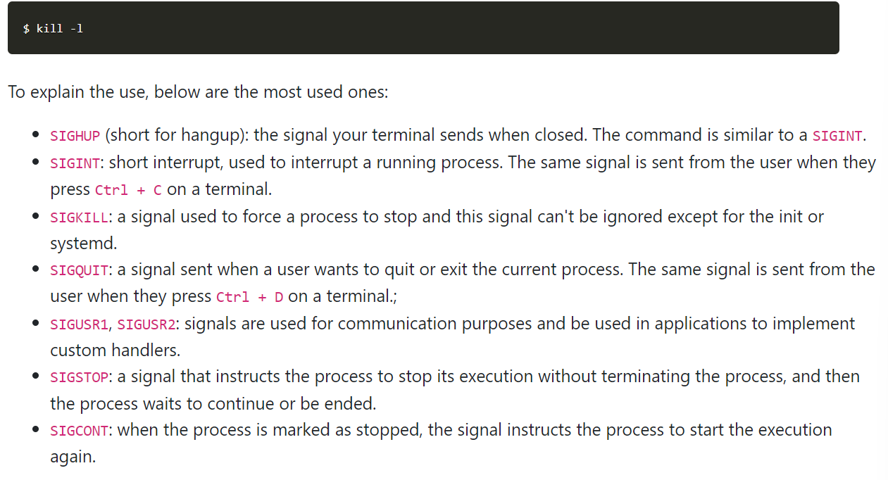
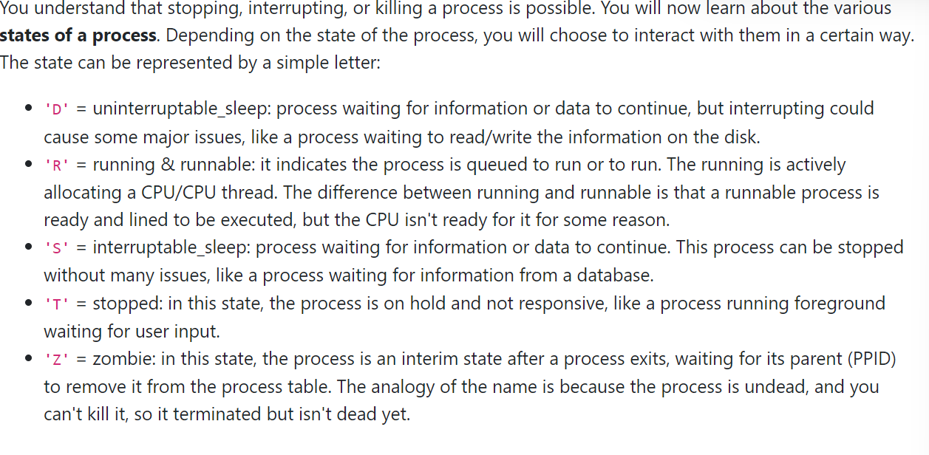

Additional commands
pgrep firefox: shows all processes called firefox. Similar to pkill.

top :to run top - do so without arguments. Running top will give a picture of a live feed that updates as new processes are started or stopped.
$ top -n <number> does what top does but includes only a limited number of lines.

Top command will first show the recap statistics about your system at the top. By default the view is updated every 3 seconds. The lower the NICE value of the process the higher priority of the process.
https://www.scaler.com/topics/linux-nice/

Notes to do
- Managing Linux Software
- Task: linux processes and software
- OSI Layer Model

Encapsulation Process
User data - the data we are actually trying to transport to another device
Control data - the info that is required for network device to be able to transport user data reliably

To prepare user data to be sent across the network we encapsulate or wrap it in control.

Following is seen from an OSI model POV
- Layer 7
  - At L7 data is a single stream of info and we refer to it as data. That is what we call PDU (protocol data unit) . It is a convenient name we use to id what kinds of control data has already been added to user data.
  - No control data has been added to our user data to this stage.
- Layer 6
  - L6 is presentation layer
  - Where encrypting data, data compression and formatting occurs.
  - At this point all user data is one large stream - no control data added yet. Its still called Data
- Layer 5
  - Session Layer
  - Some process come in responsible for helping to set up and maintain connections
  - At this point all user data is one large stream - no control data added yet. Its still called Data
- Layer 4
  - If data is too long here it may be interrupted. So we break the data into segments
  - Each segment is sent separately and combined at the destination again. With marks for the order
  - At L4 the data is (L4 header)(user data)
- Layer 3
  - At this stage IP addresses are added - one for host one for destination
  - At L3 the data is (L3 header)(L4 header)(user data)
  - Now its called a packet
- Layer 2
  - The encapsulation process is adding another set of address to out packets
  - This time physical addresses - 2 of them again
    - MAC addresses. For source and destination
  - Now our user data is essentially ready to travel so we will also include some basic error checking on control data.
  - MAC addresses id the source and destination in the next leg of the journey across the network
  - (L2 header)(L3 header)(L4 header)(user data)(L2 trailer)
- Layer 1
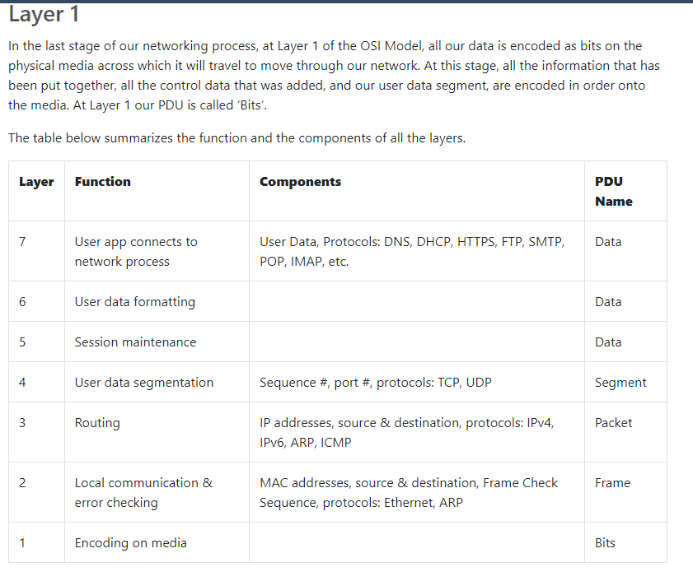

Encapsulation Process Demonstration
scenario the user of workstation 01 is accessing the HTTP web server on server 02. The station must go through router 03, which is the workstation's network gateway, in order to reach the server.
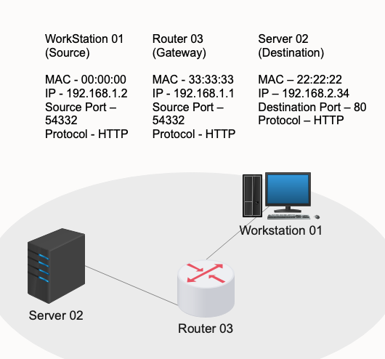
- Source IP address and port: 192.168.1.2 and 54332
- Destination IP Address and Port: 192.168.2.34 and 80
- Source and Destination Mac Address
- Network Protocol.

Demo Image notes
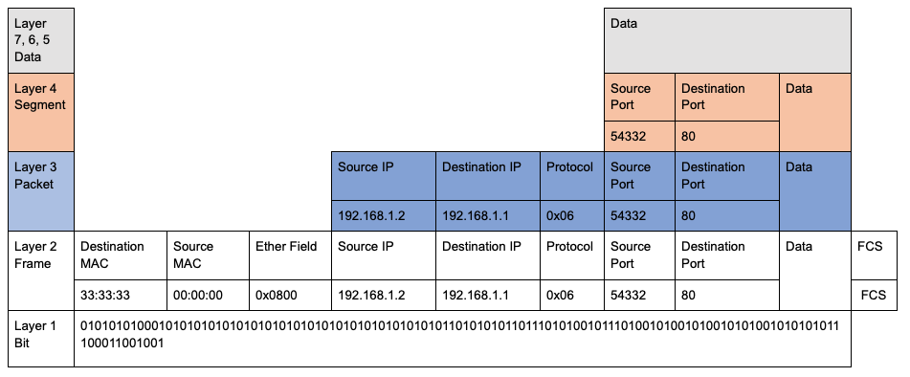

Notes to do
- Encapsulation Process Demonstration
- Packers on the Network
- IP address IPv4
- Ip addresses IPv6
- Intro to AI

Handshake explanation: https://discordapp.com/channels/984170040481964052/1255633176844566560

Day 3
Laptop monitors?
https://www.amazon.ca/dp/B0CPXCHZC8/ref=sspa_dk_detail_1?pd_rd_i=B0CPXCHZC8&pd_rd_w=XgCGk&content-id=amzn1.sym.516c2169-755e-413a-a38a-68230f4ab66f&pf_rd_p=516c2169-755e-413a-a38a-68230f4ab66f&pf_rd_r=2R7BK1DBCQKD658NQSWW&pd_rd_wg=5nH4S&pd_rd_r=7fadb615-9448-4fcd-8a36-8552ac37b775&s=pc&sp_csd=d2lkZ2V0TmFtZT1zcF9kZXRhaWw&th=1

Frame Makeup By Protocol Headers
Wireshark is a free open source network traffic inspection tool.
Captures and displays real time packets for offline analysis in human-read format w microscopic details. Wireshark requires basic networking knowledge and analyzing security tools.

Capabilities
- Cross-platform - software installed and used on multiple types of PC
- Captures packets from network media (think LAN. ethernet, USB.. etc)
- Opens captured files by other software (transferrable and interchangeable)
- Saves and exports captured packets in many forms and provide description support for many protocols
- Provides a wide variety of statistics about network, general info, number of packets, specific protocols and hierarchy. Additionally IPs, traffic and graphical options for visualization

Intro to WireShark filtering and Analysis
Communication happens by sending packets to one another. As communication occurs on a network - its called network traffic and to view this traffic we can use wireshark to analyze it.

Wireshark gives a visual breakdown of the communication between two devices within a network.
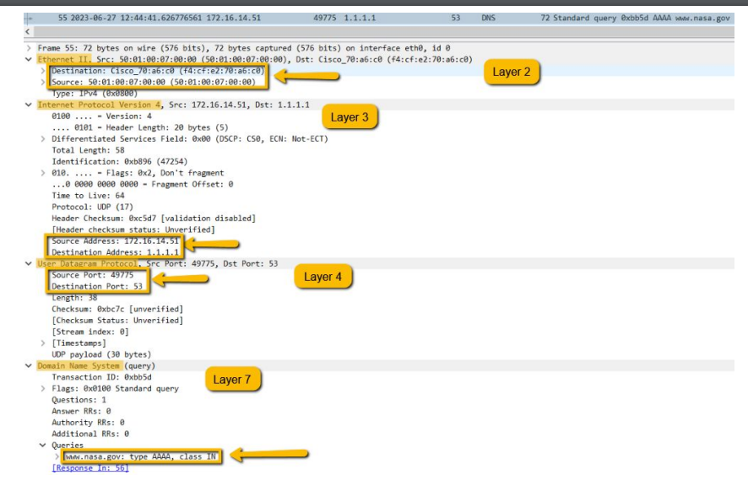

Understanding Wireshark
Each line within Wireshark is a one-way communication (one line per direction of communication - texting idea). Source: is the IP address of device talking. Destination: is the IP address of device receiving the communication. While Protocol is the rules being used to facilitate the communication.

Example
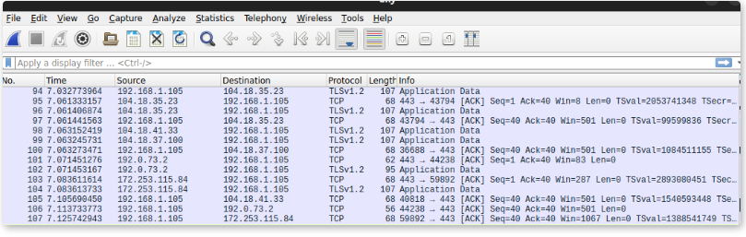
- Line No. 100, what is the source IP?
  - 192.168.1.105
- Line No.97, what is the destination IP?
  - 104.18.35.23
- Line No.105, what protocol is being used?
  - TCP

Filters in Wireshark
Filters allow for narrowing down results to find what we are looking for rather than being overloaded with large amounts of data. First option to do this is called display filter -allows specific search terms which limits results displayed. Using the filter does not remove any captured data but rather instead hides the data we are not interested in. Additionally we can change the dynamics of the search when we prefer.

Shows how to filter by a protocol
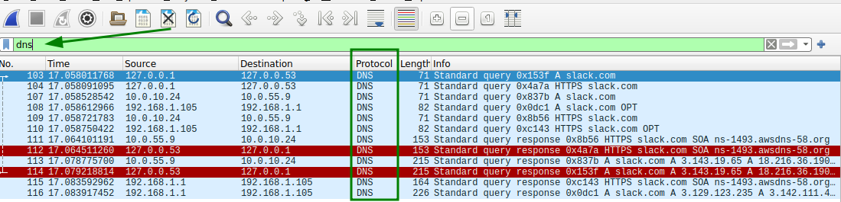

Can also search for specific Ip addresses, syntax for such a request is ip.addr == <ip-address>
Able to combine filters with the word and. ‘ ip.src == 192.168.1.105 and dns’

- What is the Wireshark Display Filter to find traffic with a Destination IP address of 172.168.1.201 using the TCP protocol?
  - ip.dst == 172.168.1.201 and tcp
- Wireshark is case sensitive.

Capture Filter
This filter allows us to focus on what we see in Wireshark, it wil only save those packets that meet filter specifications we choose and disregard other packets.
- Key difference of capture filter is that when using it - traffic not meeting specifications are not captured. Thus unable to review alternative sections of traffic later. This means less space is used for storage but we may miss something important if not careful

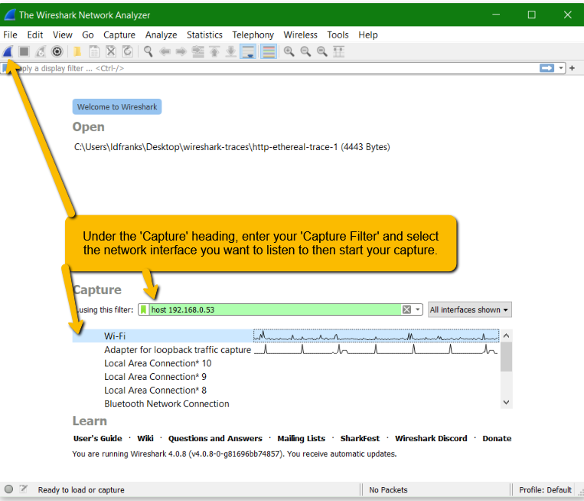

Additionally - capture and display filters are not interchangeable. Some aspects can be filtered by one but not the other.

- Wireshark, Display Filters
- Wireshark, Capture Filters

Filter Table
 | Capture Filter | Display Filter
When applied | Before taking packet capture | After taking packet capture
What is captured | Only what is stipulated specifically | Everything the chosen network interface sees
capture size | Smaller size. Limited to only what is asked for | Large, captures all packets seen on the network
Changeability | Cannot be changed once capture is started. Should be planned careful and thoroughly | Can be changed often . capture is already complete before use
Effects on packets saved in the capture | Affects what wireshark will save for packet capture | Does not affect what packets are saved by wireshark

IP Lab
Uses traceroute command.
- Typing it in browser means it first connects to my router - then Internet provider - then other network infraustrature before eventually google. These stops are called hops
- Continuing after chat with Emily

Tasks,,,

ARP lab, TCP lab

What is VLAN?
Due to the complexity of modern computer networks it is common for physical networks to be made up of several logical networks. Called Virtual Local Area Networks (VLAN). Aka a logical network where you can group several devices according to unique criteria together.

Why VLAN
Mainly VLANs allow for segmenting physical networks into smaller more secure subnets, reducing data breach concerns. A VLAN switch is a network switch that can create multiple virtual networks on one single physical infrastructure allowing for ideal organization, security and performance.

- Organization
  - Different departments can have their own VLAN, allows for different users to be in different locations
- Security
  - Visitors don't need access to critical information or servers (so separate VLANs)
- Segmentation
  - Allows for easy divide of physical network into smaller logical networks
- Extension
  - Extends virtual switches across multiple physical switches over locations
  - Remote work vibes

VLAN tags
VLANs are faa link layer (layer 2) technology with VLAN tag inserted into the header. The tag is a small piece of data added to the network packet to help identify which VLAN the packet belongs to.

The standard layer 2 header is the ethernet header including:
Destination MAC address, source MAC address and type.

When an ethernet frame enters a switch, the switch will insert the VLAN tag between source MAC and type. Like the apartment number with postal codes. The tag will be removed before the frame is passed out to other devices on the network.

Readings
CBT Nuggets, What is a VLAN and How They Work
ComputerLanguage.com, Definition: virtual LAN

Network Segmentation
VLANs are essentially a switch’s way of understanding what packets should go to what device that they are connected to.
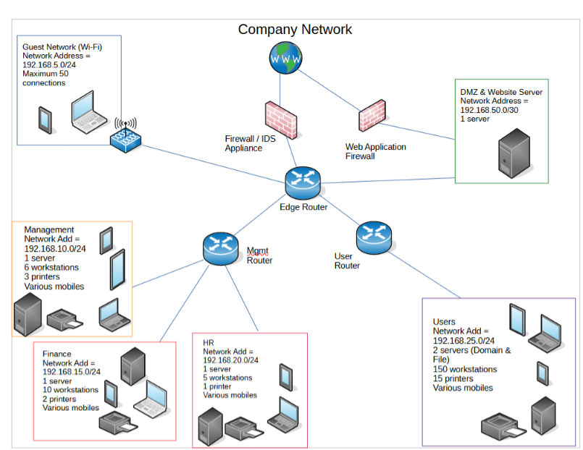

Reasons for example separation
- DMZ & website server - hosts the company website and publicly accessible so we want to separate it from internal to protect internal data
- Management - employees have access to key info but want to control eavesdropping
- Finance - same as management but sensitive info and don't want everyone knowing the banking details
- etc.

What does a VLAN number mean? With different numbers for different separations of the network.
-numbers are randomly assigned - usually round but options exist

Segmentation details.
- The VLAN # does not need to match the network address but it can help keep simplify admin pov
- Do IP ranges have to be /24?
  - No - IP address ranges can be subnetted to make them better fit the amount of devices.
  - For the bootcamp we mostly use classful addressing.specifically class C - which has a /24 subnet mask
- Separating by department is common but alternative separations can be arranged. Not required to be by department
- The limit of VLANs and/ or IP ranges that can be assigned is quite large.
  - Thousands and thousands. Specific limit not necessary

Group share and Feedback
Task
- Job Roles: Consider how the network might be structured based on the roles within the organization.
  - Level of clearance and knowledge set that comes with job title would likely mean separation of VLANs
  - ex) cashiers & POS can be separate network then those of security guards and delivery transport
- Geography: Explore how the network might be organized based on the physical location of different departments or teams.
  - If teams of one speciality are all in one building while another team of a different speciality is in another building then it would make sense to have different VLANs for each building and potentially each speciality within a building
  - The use of multiple locations but same permissions would also require multiple VLANs as the remote workers would need access but likely not the same security needs as those physically working at the company office.
- Department: Analyze the potential topology based on the distinct departments within the company.
  - Departments tend to be grouped by specific skill sets - finance, IT, human resources etc. thus each department need access to different areas of the network that can be easily identified based on your department
~~~~~~~~~~~~~~~~~~
The list of devices:
- 1 Windows Server machine that contains an SQL database, acts as the company domain server, and also provides file share services
- 1 Linux server machine that hosts the company website
- 2 Kali Linux machines used by IT staff for managing and maintaining the company infrastructure
- 12 Windows Workstation machines used by end users in the organization to complete their jobs
  - 3 of these are used by management
  - 2 are used by HR
  - 2 are used by Finance
  - 5 used by various other users in the company
~~~~~~~~~~~~~~~~~~~
Individual pov
- What might the topology look like from your perspective?

Website
Windows Server/ Database
IT Dept
2 HR PCs
2 Management
PCs
2 Finance PCs
5 Various users
1 Special management

- What are the key points to consider?
I assumed 2 management wasn't technical. Additionally Website and the server access need firewall protections to ensure security

- What are the pros and cons of grouping the topology in this way?
Management could likely be grouped better and the IT department must go tho the main server to help the other sections of the company

- Are there any concerns regarding company growth or significant changes?
Not easily scalable with this topology

Mentor help - networks
https://discord.com/channels/984170040481964052/1255692806022893588
- VLAN numbers are randomly/ optionally assigned to indicate the sections.
- Routers are meant to pass packets and do have some firewall capacities but not as strong
- Firewalls are like bouncers - better security but not the solution
- Best to segment your networks to protect from malicious attacks spreading and port limitations
  - Segmenting meaning IP ranges for subnets
- Firewall cores in network topology works for small companies but not large ones. For large companies; firewall cores can cause performance bottlenecks, single point of failure, vendor lock in and disaster recovery problems. Etc.
- 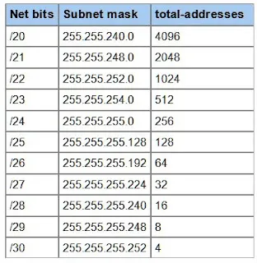
- https://jodies.de/ipcalc for IP calculations

Firewall Technologies
Firewall is a hardware or software based security solution that analyzes network traffic based on rules and instructions to determine which data transmission can be done. Blocking unwanted traffic and frees up authorized access to ports

Can image firewalls as gates of a company - to enter certain conditions must be met like ID, belongings and leaving with only your belongings.
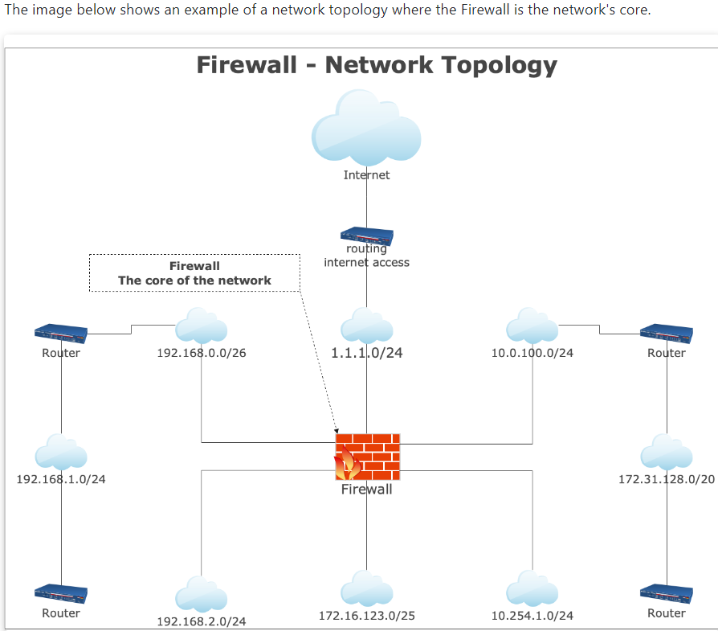
This topology can prevent a series of malicious actions. A firewall is a barrier that checks what data can and cannot pass - thus the need for established policies and rules

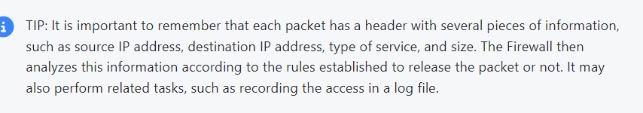

Firewall Types
How firewalls work varies - some factors like developer criteria, specific needs of protection, OS characteristics, network structure etc.

Packet Filtering: First firewall emerged in the 1980s based on packet filtering (a straightforward methodology that limits but also with high security level).

Data transmission is based on TCP/IP and filtering is usually limited to network or transport layers. Network: equipment and routing processes are addressed. While transport layer : protocols that allow data traffic is located, (user datagram protocol too)

Application Firewall
Also known as proxy services /reverse proxy/ or proxy. Security solution that is an intermediary between a computer and internal network and another external network. Traditionally installed on powerful servers that dealt with numerous requests as the firewall does not allow direct communication between source and destination. (no direct communication between servers and users).

This kind of control also makes it possible to use the proxy for complementary tasks like record data traffic in logs. A proxy regularly hides a genuine network address, intercepts all messages in and out of the enterprise and screens them by the security policy. Implementing a proxy is challenging and this type of firewall is only able to or requires few configurations to block or authorize specific authorization.

Stateful Inspection
Considered an evolution of dynamic filters that works by comparing what happens with packets to what is expected. Inspection Firewalls analyze all data traffic to find states and compare patterns to what is acceptable by there rules. The firewall then keeps the information and is used as a parameter for subsequent traffic. Blocks unexpected traffic or port access etc.

Personal Firewalls
Are simple software firewalls designed to protect PCs regardless of the type of computer. Can be installed as a module of antivirus or be pre installed on a PC.

NGFW = next-generation firewall is an example of more specific internal security systems that offers extra reinforcement

Modern advanced firewalls operate at the application layer of network stack. Application firewalls apply filtering rules by process rather than connections or ports, NGFws employ methods to do deep packet inspections, protecting TCP/IP stack. As a module of the NGFW, complex intrusion prevention systems defend against signed/unsigned attacks.

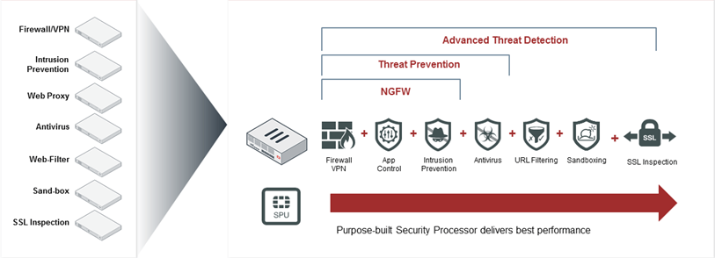

VPN Technologies
VPN = virtual private network
A method to establish secure, encrypted, privat connection between two different networks on a public network. The process makes third party tracking and data stealing difficult as the VPN encryption work ins real time

VPN types
- Remote Access VPN

Day 5

Traffic Monitoring
Network admin are requested to add new services, users, technologies and applications. Still these changes can affect the ability of consistent and predictable network performance. When these issues arise it's important to verify the root cause before it impacts the entire network.

- Intermittent network performance issue is difficult to replicate and diagnose
- Need to understand how everything connects as a performance problem in one area can

NMS = Network Monitoring System
Five key areas of NMS → discover, map, monitor, alert, report

- Discover
  - NMS discovers devices and can include a library of monitoring templates that define how to monitor devices. All these functions are vendor-specific. A monitoring system with layer 2/3 discovery will find port-to-port connectivity (includes mac and IP).
- Map
  - NMSs generate network maps, a powerful first response tool that allows visualization of the network. Visualization saves time in troubleshooting network issues and simplifies even complex and messy networks
  - Some software provides drawing tools

- Monitor
  - NMSs expose many monitors and templates to network admin. To start monitoring, network admin should look at the main five.
    - Availability, latency, CPU, memory, disk and interface utilization.
  - Most network monitoring tools look at power supplies, temperature and fan speed
  - When configured well, NMS will provide a visual dashboard of devices their functions, real-time failures, advance warning of imminent failure.

- Alert
  - Key for monitoring and notifying when something goes wrong - threshold based alerting allows quick response to unusual behavior.
  - Central alert management: NMSs provide real time data monitoring
    - Validate network projects are desired results
    - Expose trends that impact performance
    - Quickly isolate and fix issues
    - Prove availability of network and connected devices

- Most NMSs are customizable with profile-based dashboards for users. NMSs differ in capability for each function but same results.

How Network Monitoring Tools Collect Information
Monitoring tools collect info by using poll connections over the network devices and servers. Receives information about performance data using standard protocols like agents, SNMP, WMI, sniffing and remote SSH.

WMI = Windows Management Instrumentation

WMI is protocol for windows-based systems and applications of Web-based enterprise management. Industry initiative to develop a standard for accessing management information - the protocol creates an OS interface that receives information. Then WMI passes all these details to network management software.

-microsoft has changed policy so some WMI commands in Powershell are no longer supported. Should be replaced with CIM cmdlets code.

Monitoring the Network with Wireshark
Wireshark allows the user to analyze packets transmitted over the network, displaying info in GUI. the program's GUI is the main difference between Wireshark and the TCPDUMP tool.

TCPDUMP provides the same details of network packet information as Wireshark but without the dashboard visual. TCPDUMP is included as a command-line tool.

Witeshark offers facilities depending on user knowledge level rather than graphic resources. Can also run it using cmd line. Both wireshark and TCPDUMP use the same library (libpcap) and thus Wireshark supports TCPDUMP.
- Real-time data readings: all packets econtent sent/received are captured an essential feature for tracking suspicious events
- Availability and interoperability for various OSs.
- Easy and intuitive filters to understand total traffic

Applying Filters
With wireshark you can apply content filters - this makes the process of inspecting traffic closely easier. Sorts large amounts of data into designated specific subgroups.
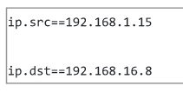
Can combine string searches with and between or Contains.
Can also filter by port and type of protocol (ie: udp.port==357)
Or combine conditions with || between two requirements. (either one or both)
Wireshark

Review Questions
You are a network administrator using an NMS. You receive an alert that the CPU utilization on a core router has exceeded 80%. What steps would you take to investigate and resolve this issue before it impacts the network?
- Verify the Alert: You mentioned looking at the CPU monitoring, which is correct. However, it would be helpful to specify that you should check the NMS dashboard to confirm the alert and review the historical CPU utilization data.
- Identify the Cause: You didn't mention identifying the cause of the spike. It's important to determine if there are any recent changes or updates to the network that might have caused the spike, such as new devices, services, or applications added.
- Analyze Traffic: You correctly suggested comparing current traffic to the baseline. However, you could also mention using tools like Wireshark or TCPDUMP to analyze network traffic through the router to identify any unusual patterns or excessive traffic.
- Check Running Processes: You didn't mention checking the running processes on the router. Accessing the router's management interface to review running processes and their CPU consumption is a crucial step.
- Apply Temporary Mitigations: You mentioned taking temporary measures, which is great. However, it would be helpful to specify some examples, such as traffic shaping or rate limiting.
- Long-Term Solutions: You didn't mention developing and implementing long-term solutions, such as upgrading hardware, optimizing configurations, or redistributing traffic loads to prevent future occurrences.
- Document the Incident: Lastly, it's important to document the incident, findings, and steps taken to resolve the issue for future reference and to improve network monitoring processes.

Using Wireshark to monitor network traffic and notice a sudden spike in CPU usage on a normally idle server. What steps would you take to investigate whether this spike indicates a potential security threat?
- Examine Traffic Patterns: Use Wireshark to analyze incoming and outgoing traffic during the spike period. Look for unusual patterns, high volume of requests, or unexpected ports being used.
- Identify Source and Destination: Filter traffic by the server's IP address to identify the source and destination of the traffic. Determine if the traffic is coming from or going to known and trusted IP addresses.
- Check for Malicious Activity: Look for signs of malicious activity such as repeated login attempts, large data transfers, or unusual protocols being used.
- Review Server Logs: Check the server's logs (e.g., web server logs, system logs) for any suspicious activity or errors that could be related to the spike.
- Isolate the Server: If a security threat is suspected, consider isolating the server from the network to prevent potential spread or data exfiltration.
- Run Security Scans: Perform a security scan on the server to detect any malware, unauthorized access, or vulnerabilities.
- Notify the Security Team: Inform the security team of the findings and collaborate on further investigation and remediation steps.
- Document Findings: Document the incident, including the steps taken and the conclusions drawn, to help prevent future occurrences and improve security protocols.

Intro to Network Baselines
Establishing a network baseline is helpful in figuring out what behaviors are ‘normal’ for a given network. When a network baseline is established it's easier to recognize unusual activity.

- bps: unit of measure that stands for bit per second. Not to be confused with byte per second (Bps)
- in/ingress: how much traffic is coming into the network
- out/egress: how much traffic is leaving the network.
- Statistics like average, standard deviation, min and max are important in establishing baseline and subsequent alerts for abnormal traffic.

Network traffic varies due to time and date. A network baseline is expected behavior including info of devices, protocols and traffic typically present. According to cisco baseline is to:
- Determine current status of network devices
- Compare status to standard performance guidelines
- Set thresholds for alerting when status is outside of expectations.

The baseline should take snapshots of the network when it's considered normal to be used as a future reference point.

Establishing the network baseline
Comprehensive data about typical usage and status of the network to compare in the future, to highlight inconsistencies. Data should be collected on various aspects of network traffic including:
- List of devices, protocols and services in use
- Amount and timing of traffic
- Patterns of communication
- Records of user and device authentication

Once established, it's easy to notice abnormal behavior. Done by monitoring in real time, comparing current activity. Changes in IP, ports, protocols that are outside of the baseline indicate potential security incidents.

…..

Visualizing what happens - window logging
In this lab, you will practice working with Windows Event Viewer and logs.
Overview guide https://www.solarwinds.com/resources/it-glossary/windows-event-log

Instruction
Document how you carry out the steps and follow the instructions given below in your personal knowledge management (PKM).

- Open Windows Event Viewer on your Windows1 machine.
- Identify at least three different types of events you can see recorded for each log.

    - Windows maintains four standard logs on each system
      - Application, security, set up and security

- Try to choose events from a number of different classifications
  - 5 types of classifications → critical, error, warning, information, audit success.
.

- Record the different types of information that are documented in each type of event you have identified.

- Give an explanation on how you think the different details in each event log might be useful to you for administrating and troubleshooting.

- Create a plan to perform two different actions on the system that you think would cause log entries to be recorded; one that you do directly on the system you are working on (ex. Successful or Failed login attempt, etc.) and one that is done to the system from another system on your network (ex. ping, Nmap scan, etc).

- Test your plan. Were you successful at getting the events to be logged? - If yes: Examine your logged event(s) and the information found in them. How could this be useful to you as a Security Professional? - If no: From a security perspective, do you think this is something to be concerned about? Yes or no and why? Document your responses in your PKM.

- Recommend three different types of events you think should be logged for security reasons. Justify your decisions and explain how having these types of events logged would be useful from a security perspective and/or from a troubleshooting perspective.

- 9. Share what specific details you think should be included when events like this are logged. Record your responses in your PKM.

Understand the environment and Wireshark
2 VMs running
Linux S public Ip 134.87.133.127

Steps to ping and tracert.
- Know IP address of another machine on network
- In windows - open wireshark and command
- Begin recording
- Command prompt - ping the IP
  - ex) ping 192.245.10.1
- Once pinged - ping a website
- Then traceroute the same website
  - ex) tracert www.nase.gov
- Once done stop capture
- Compare..

In Wireshark
Identify 3 sets of communications you initiated.
- Ping of other device
- Ping of website
- traceroute

Record the info like source, destination, port number, protocols

ICMP = internet control messages protocol.
What different types of ICMP communication is identifiable
- Https,
- TTL flag - changes as each set of communications

- Where to find TTL settings

- What does TTL indicate
Time to Live - hop limit

Check the Commands
17 Best Linux Networking and Troubleshooting Commands for Beginners

Test communications between Kali and other VMs
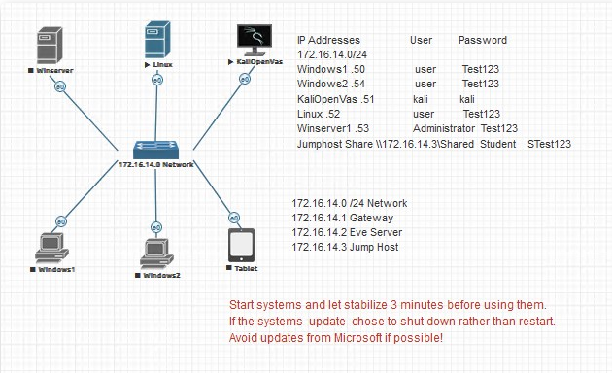

Act as a security analyst
- Confirm that all of the other servers in EVE are reachable from the Kali Linux machine.
- Confirm all traffic to the other servers is contained in the network by identifying the IP address of all the hops used in communicating to each server.
- Get the IP Address of the Kali Linux machine so that your manager can perform similar tests from the other machines to the Kali Linux machine.

When all tests are done, draft an email to the network manager explaining the entire process you used to accomplish the three objectives.

Need to test the communication between kali and all other devices on the network
- Turn on all devices
- Test network layer access between kali and other devices
- Take screenshots of findings
- When all tests are done - draft an email to network manager (create fake name)

